**SPARK Data Frames**

**Student Name: Nabh Sanjay Mehta Student Id: NSM190002**

**Date: 04/16/2020**

Step-1: Open the terminal application on the Cloudera VM desktop.

Q. Take a screenshot of the terminal application and paste it below.

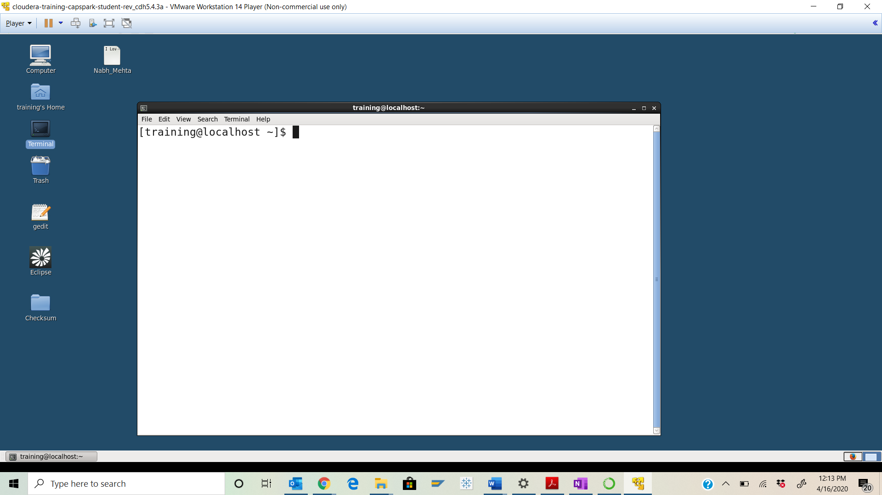

Step-2: Execute the following command at the python spark shell prompt:



Q. Take a screenshot of the python spark shell output and paste it below.

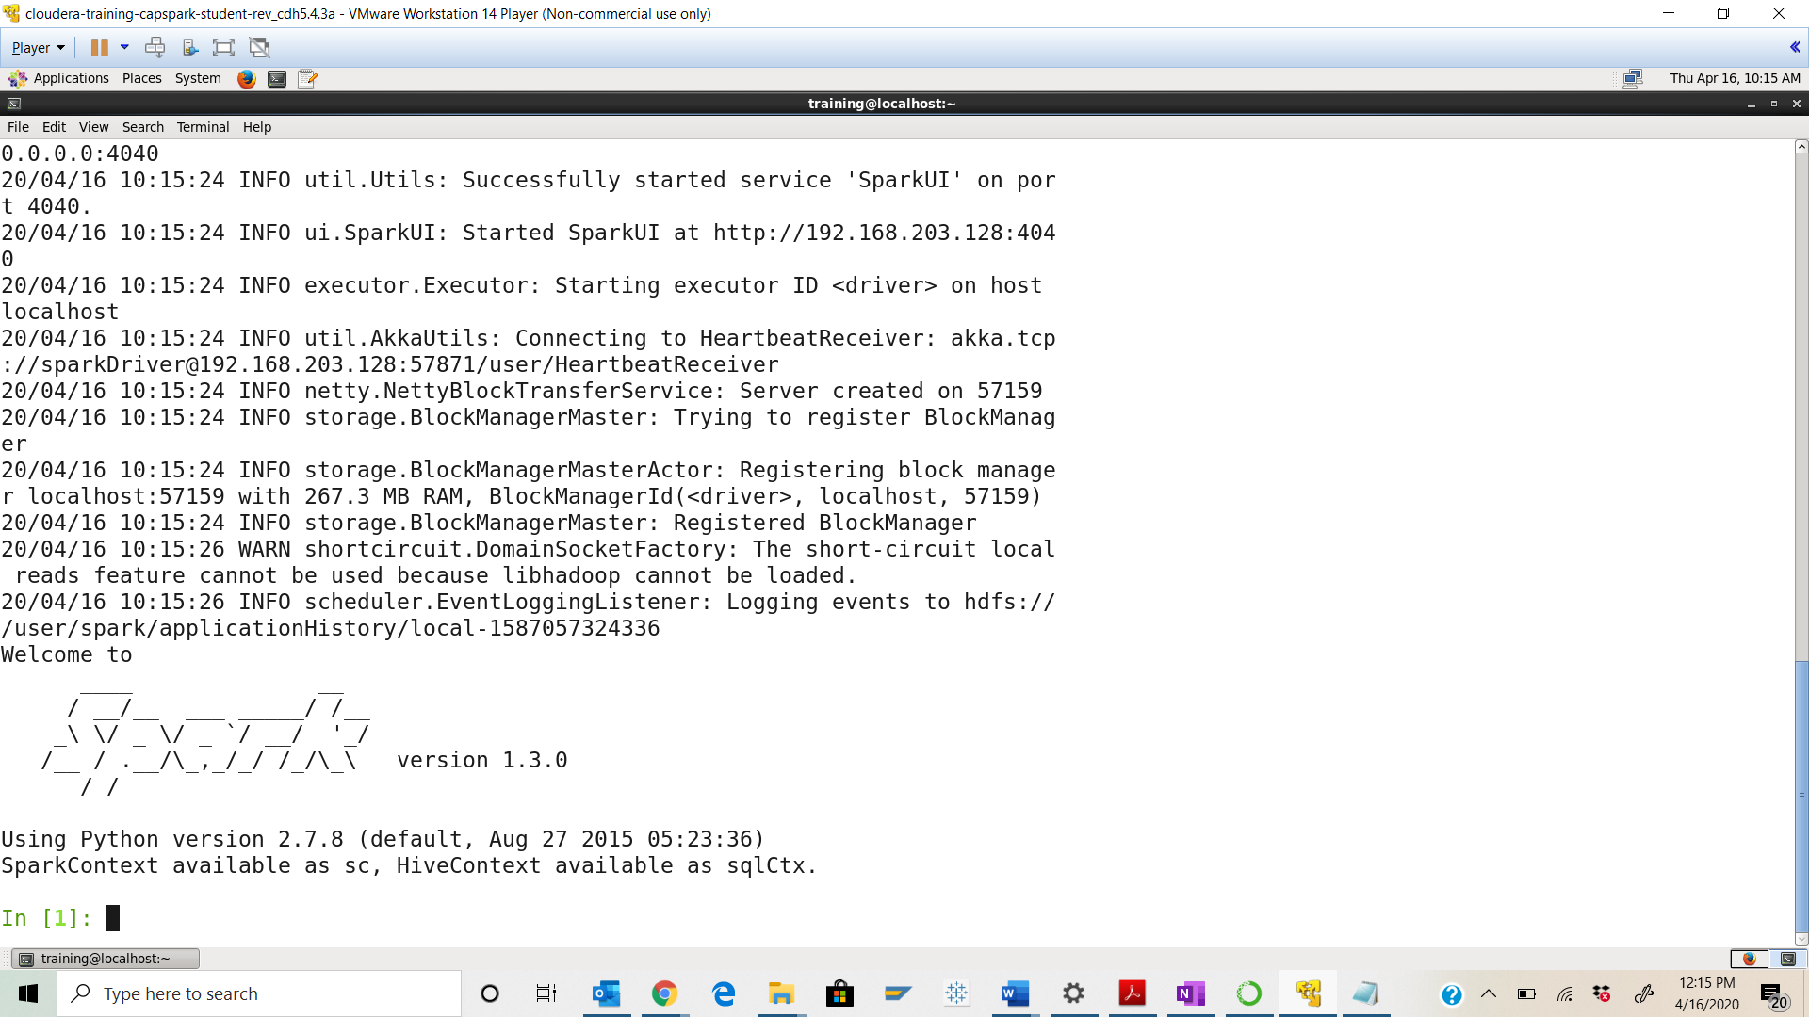

Step-3:Switch back to the terminal tab running the python spark shell and execute the following command at the python spark shell prompt:

Q. Take a screenshot of the python spark shell output and paste it below.

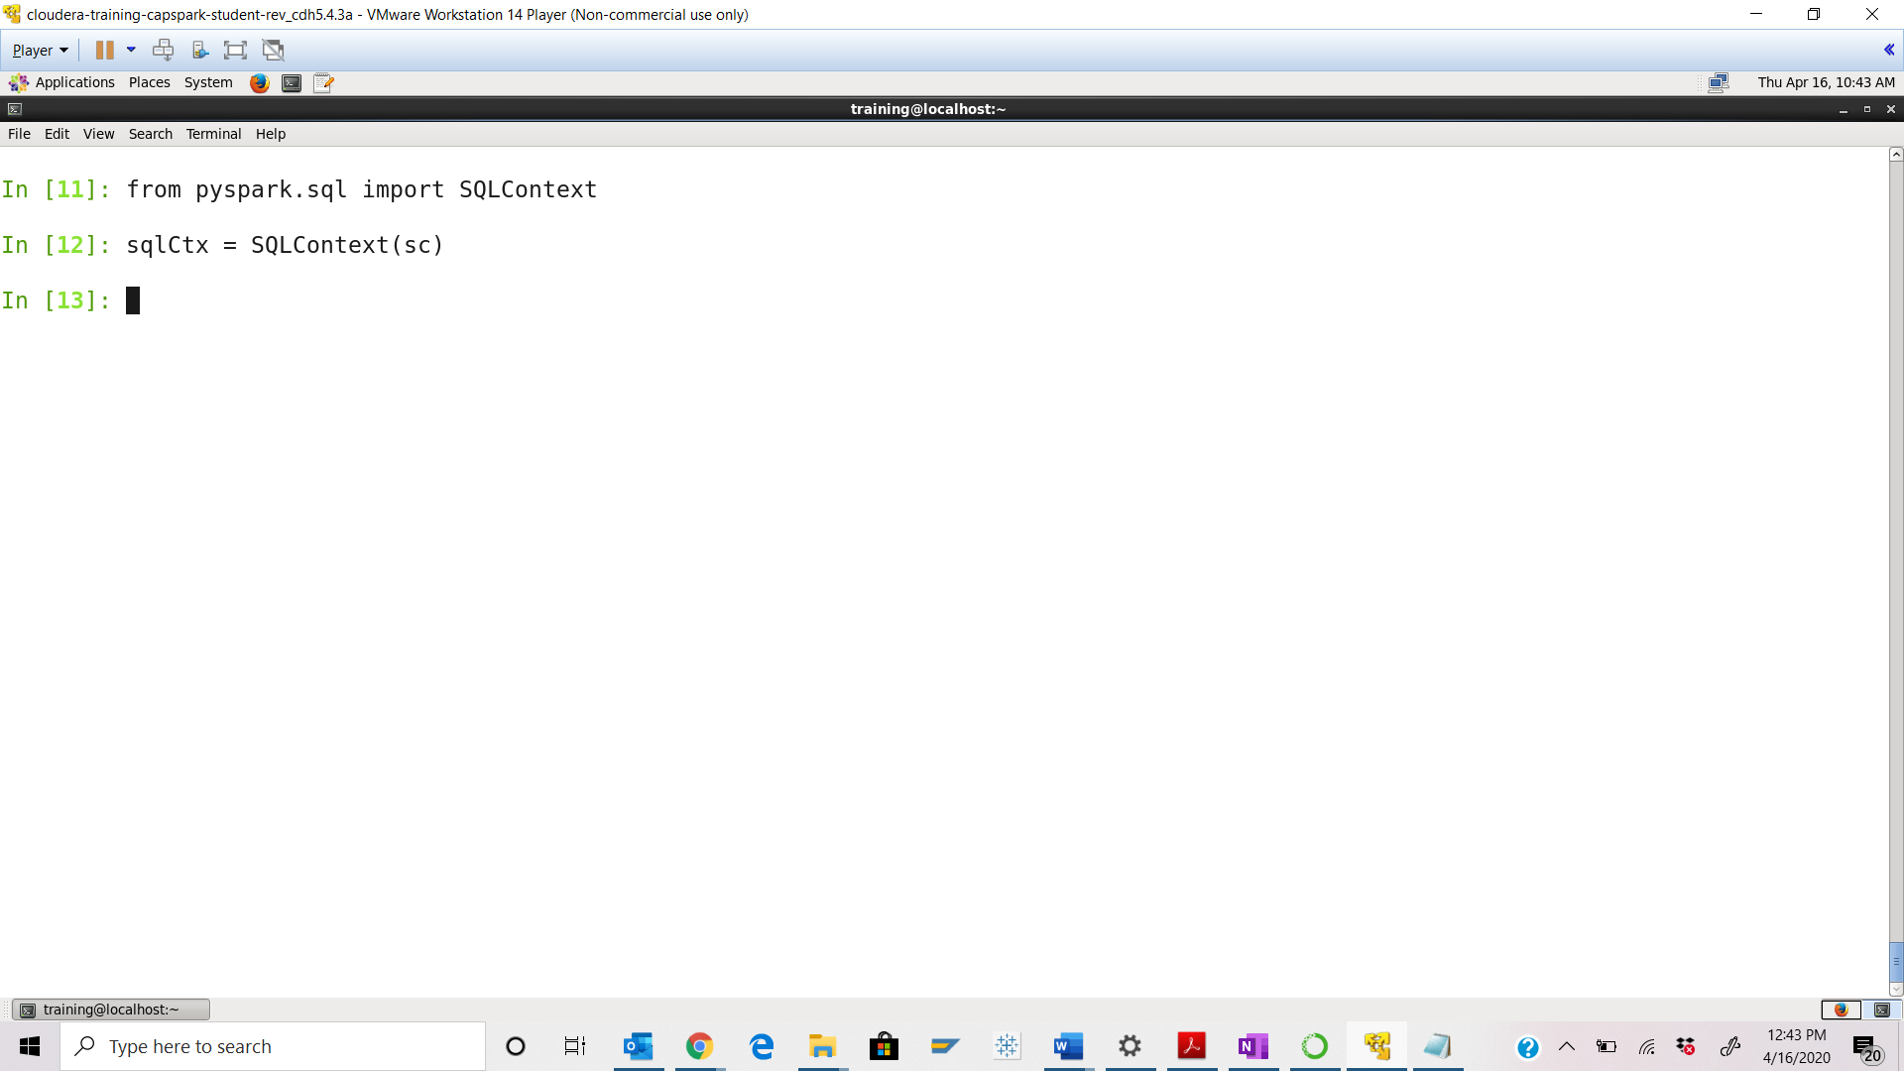

Step-4: Execute the following command at the python spark shell prompt:



Q. Execute the command below and take a screenshot of the python spark shell output and paste it below.



How many partitions are there in the resulting RDD? **– 1 as highlighted below**

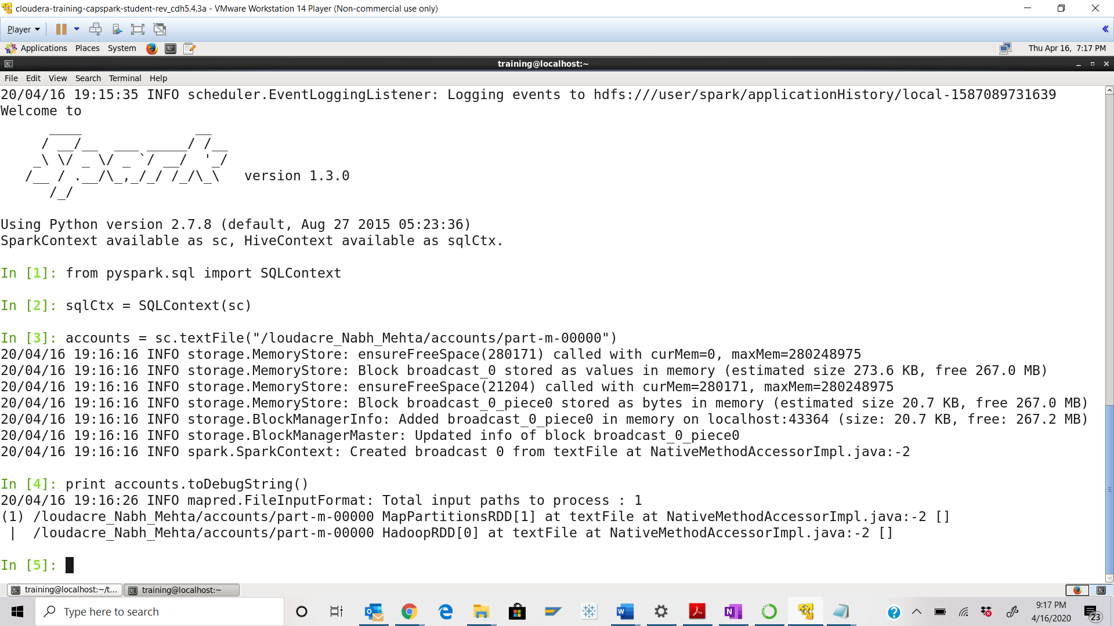



Step-5: Execute the following command at the python spark shell prompt:



Q. Execute the command below and take a screenshot of the python spark shell output and paste it below.

How many partitions are there in the resulting RDD? **– 3 partitions as highlighted in Yellow**

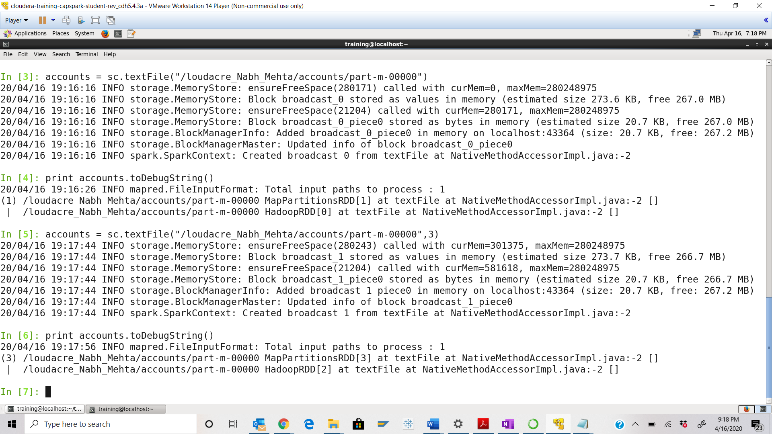



Step-6: Execute the following command at the python spark shell prompt:



Q. Execute the command below and take a screenshot of the python spark shell output and paste it below.



What is the key for this RDD?

Keys are account ids from 1 to 10 here

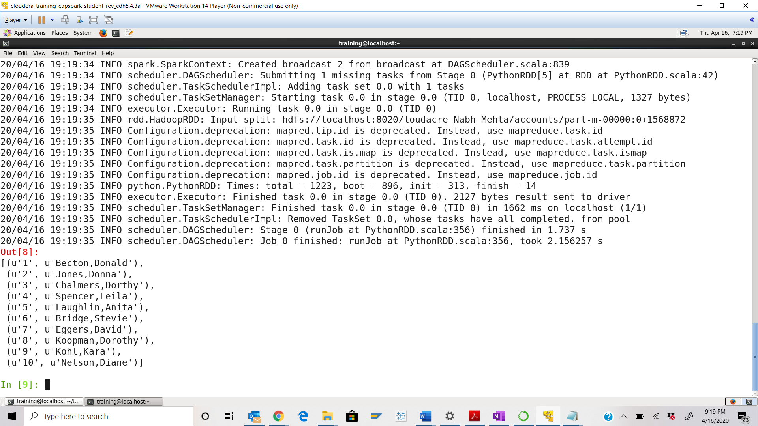

Step-7: Execute the following command at the python spark shell prompt:



Q. Execute the command below and take a screenshot of the python spark shell output and paste it below.



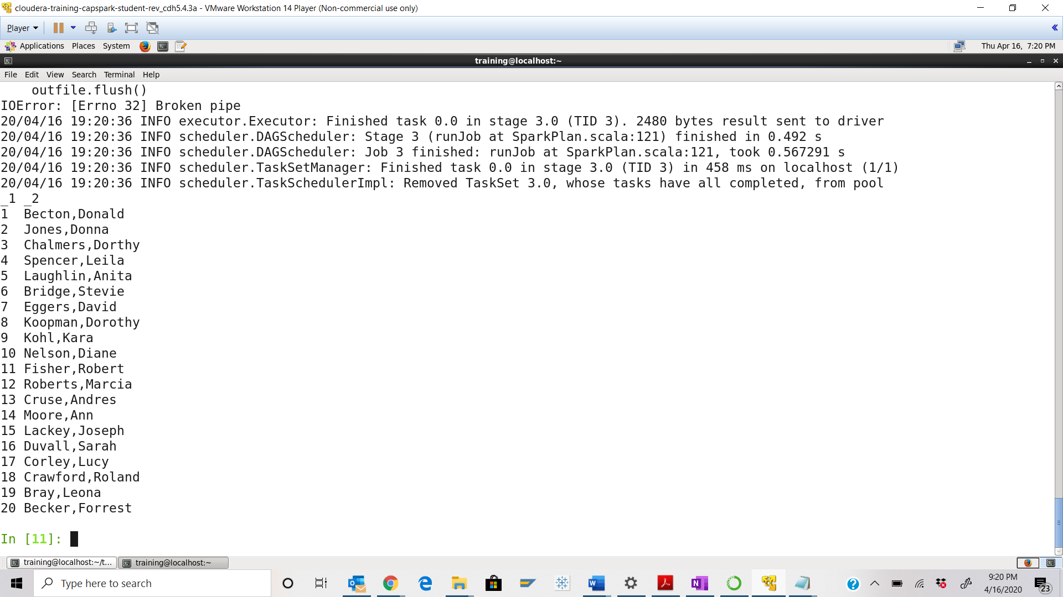

Step-8: Execute the following command at the python spark shell prompt:



Q. Take a screenshot of the python spark shell output and paste it below. What does the above operation do?

**Ans:** The above operation is reducing key value pairs by combining values with same keys.

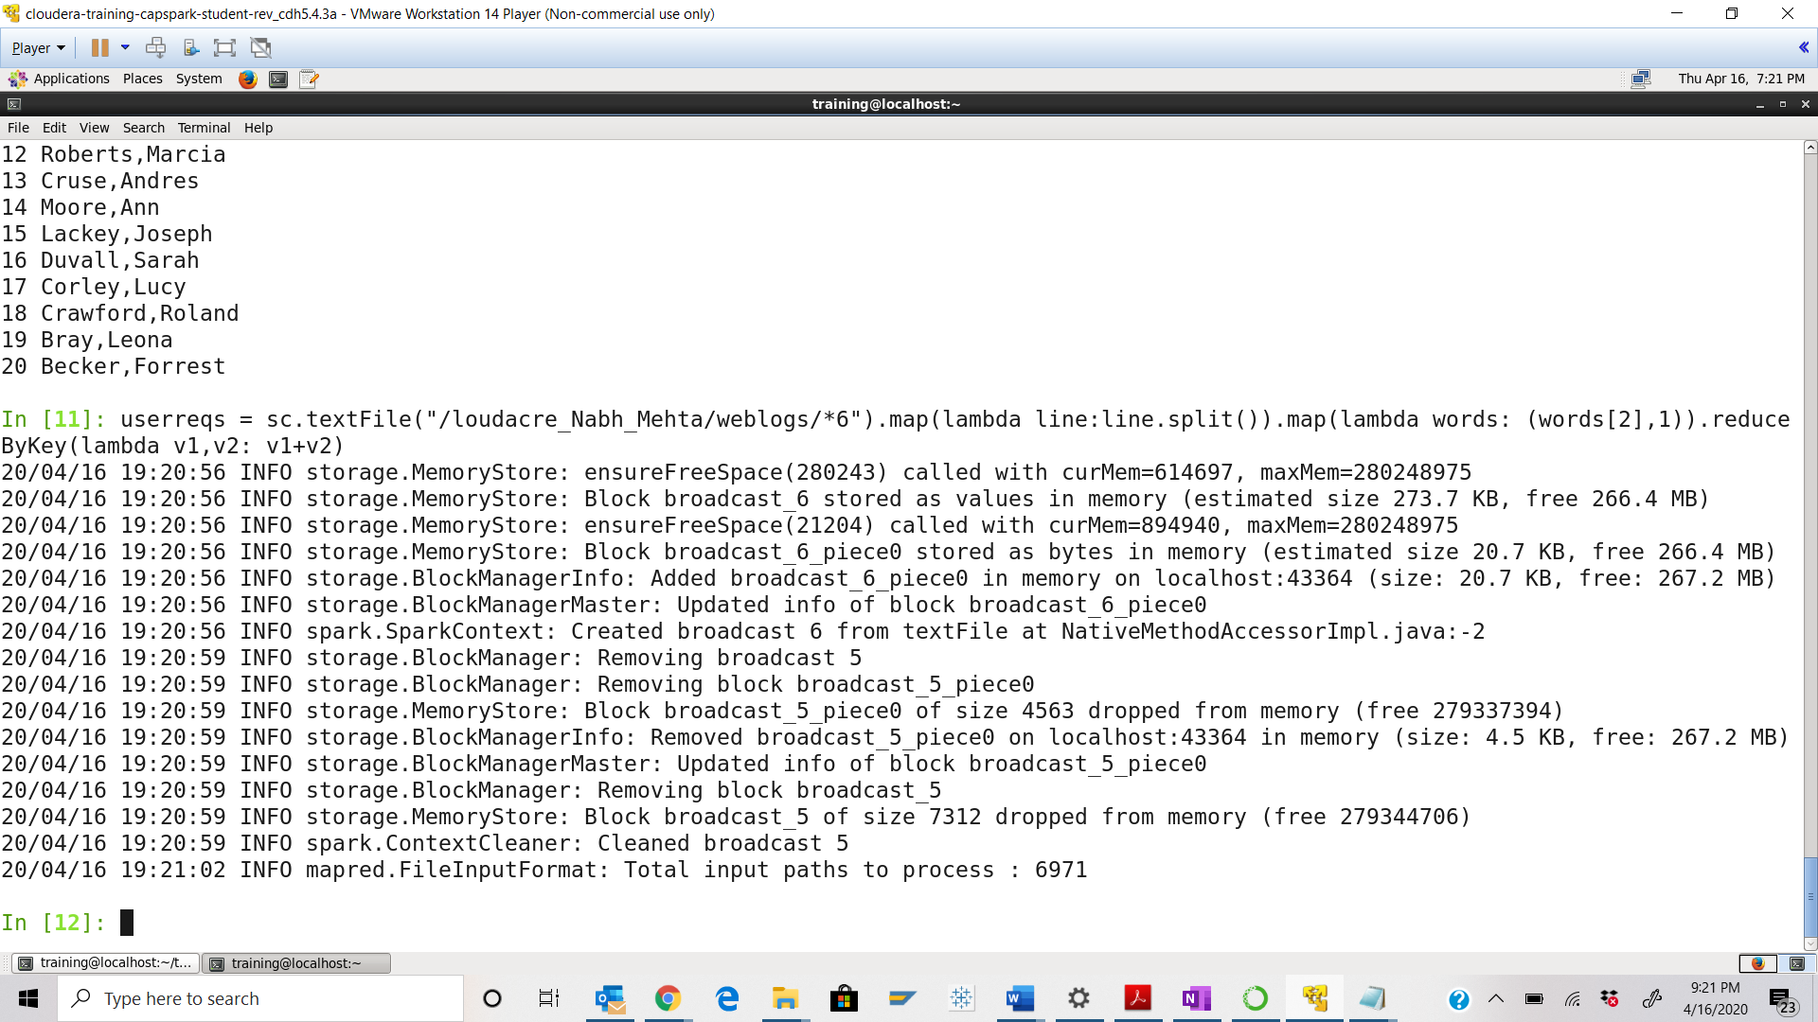

Step-9: Execute the following command at the python spark shell prompt:



Q. Execute the command below and take a screenshot of the python spark shell output and paste it below.



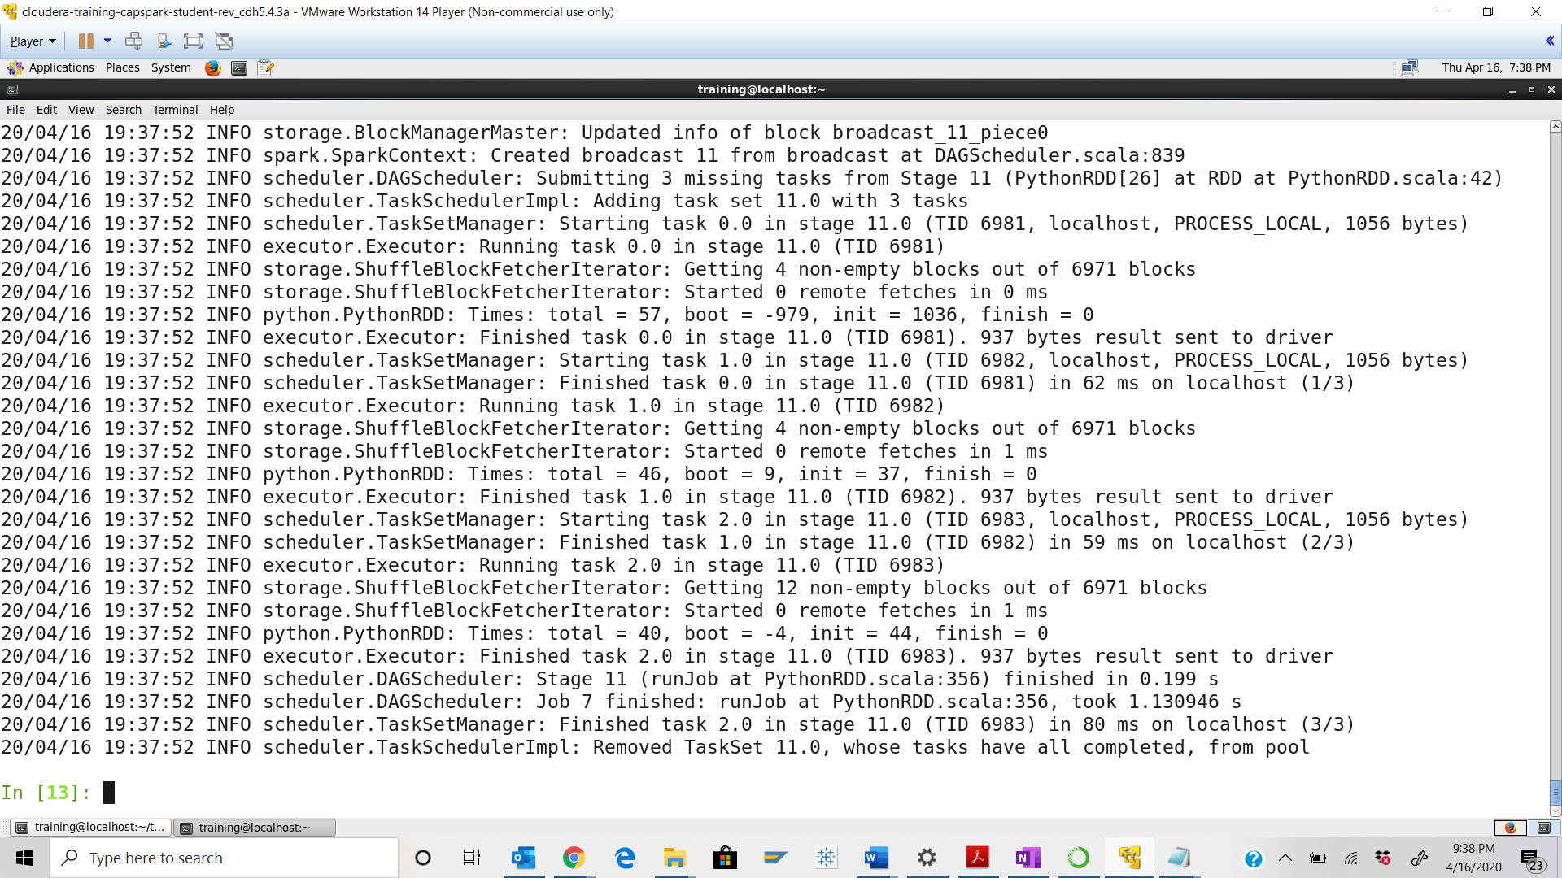

Step-10: Execute the following command at the python spark shell prompt:



Q. Execute the below command, take a screenshot of the python spark shell output and paste it below.



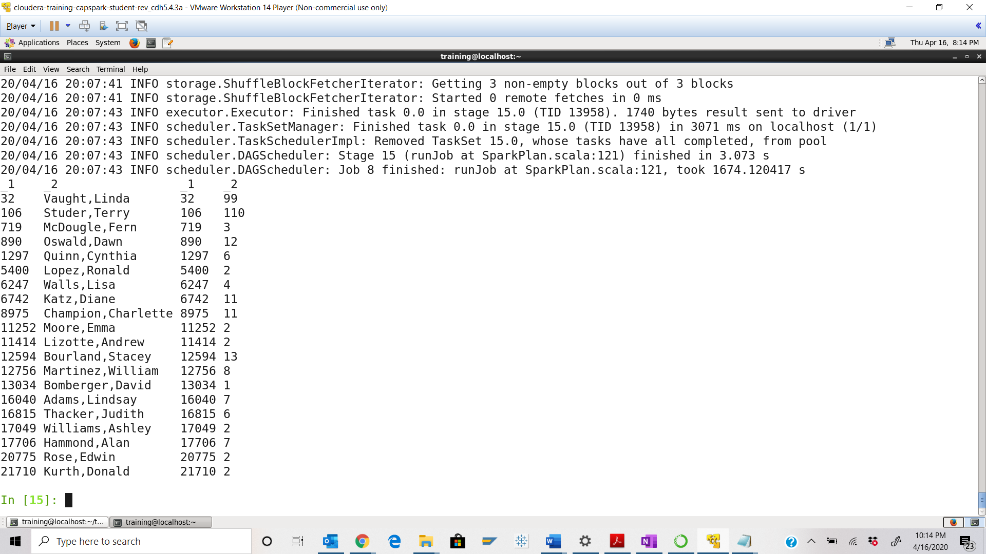

Step-11: Open the Firefox browser and click on the Spark Application UI bookmark in the toolbar as shown in the screenshot below.

Q. Take a screenshot of the Spark Application UI splash screen and paste it below.

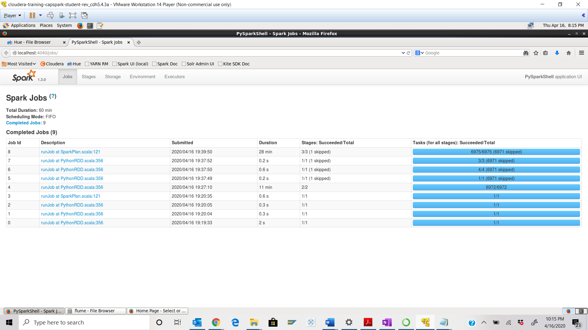

Part-2: Spark SQL: Spark SQL is a Spark module that is used for structured data processing that is built on top of core Spark. In this exercise we will use Spark SQL to load data from MySQL, perform transformations and save it to HDFS.

Step-12: Open a separate terminal tab by clicking on “File” then “Open tab” as shown in the screenshot below.

Q. Take a screenshot of the shell prompt in the new terminal tab and paste it below.

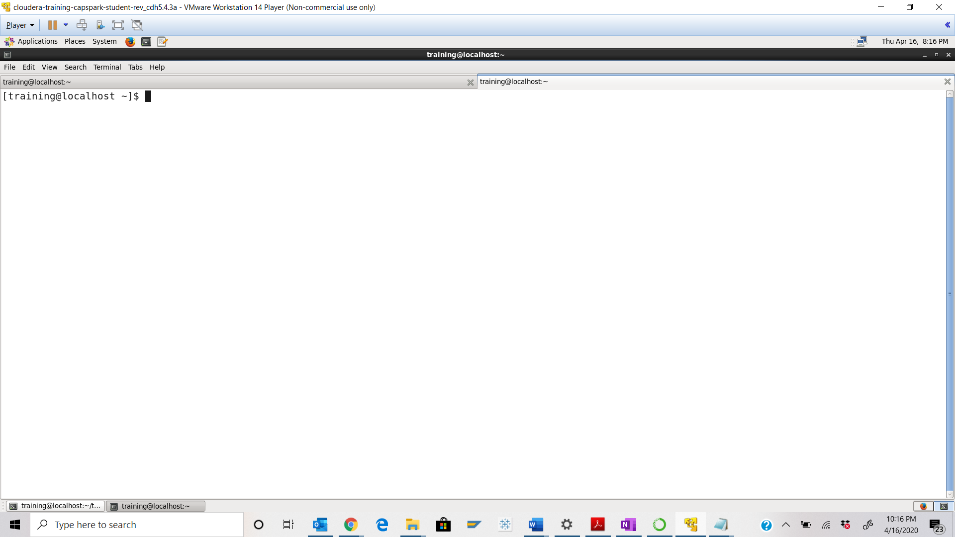

Step-13: Execute the following command at the shell prompt:



Q. Take a screenshot of the shell output and paste it below.

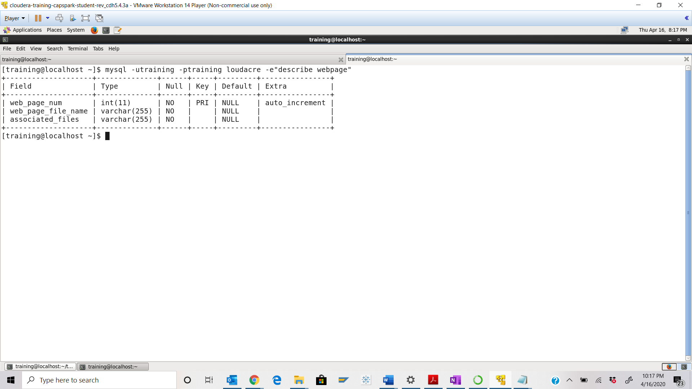

Step-14: Execute the following command at the shell prompt:



Q. Take a screenshot of the python spark shell output and paste it below.

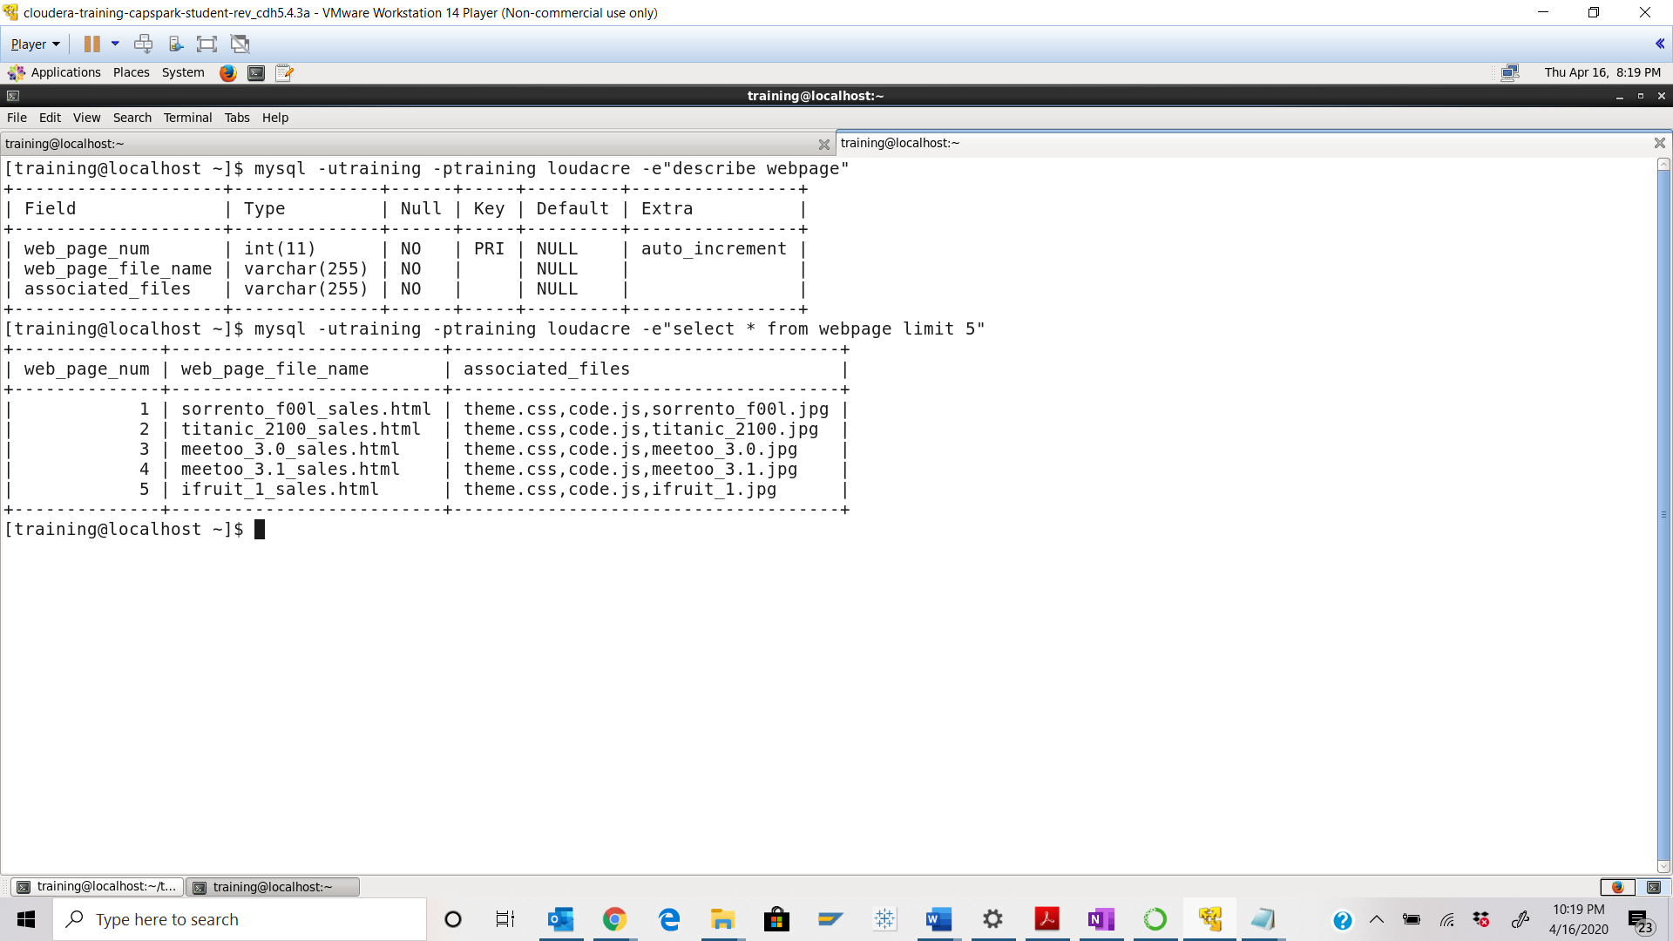

Step-15: Execute the following command at the python spark shell prompt:



Q. Execute the below command, take a screenshot of the python spark shell output and paste it below.



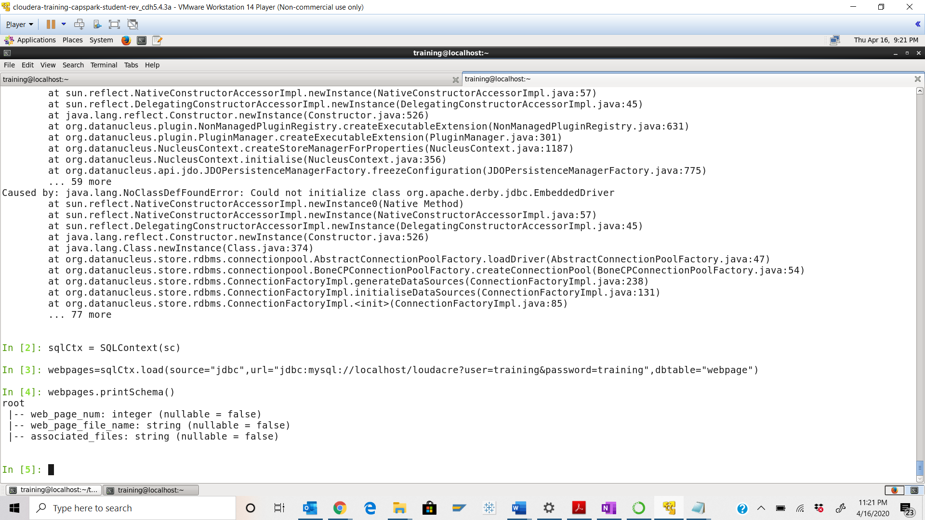

Step-16: Execute the following command at the python spark shell prompt:



Q. Execute the below command, take a screenshot of the python spark shell output and paste it below.



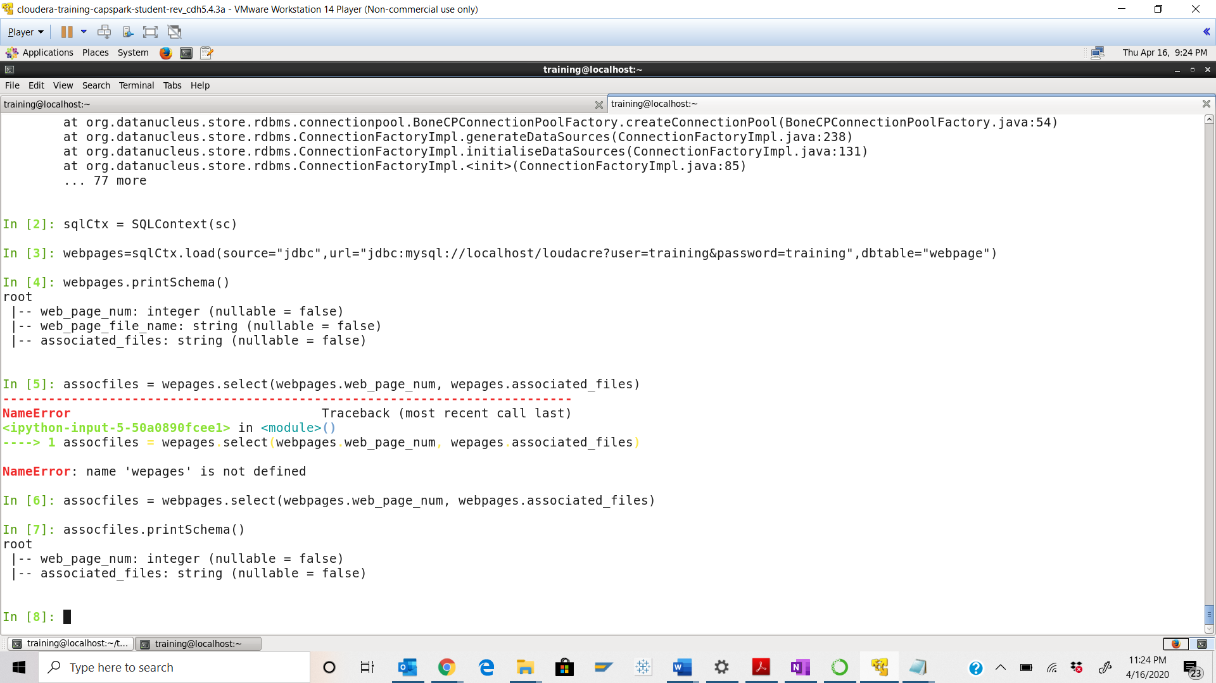 Step-17: Execute the following command at the python spark shell prompt:



Q. Execute the below command, take a screenshot of the python spark shell output and paste it below.



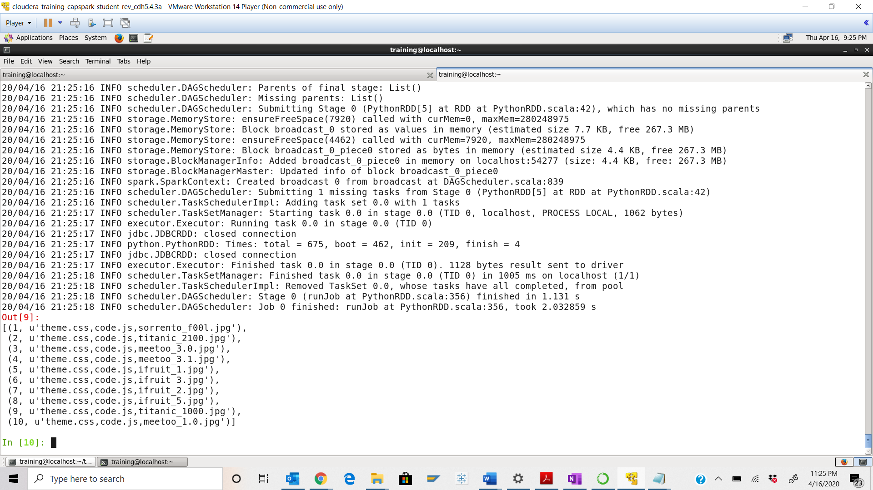 Step-18: Execute the following command at the python spark shell prompt:



Q. Execute the below command, take a screenshot of the python spark shell output and paste it below.



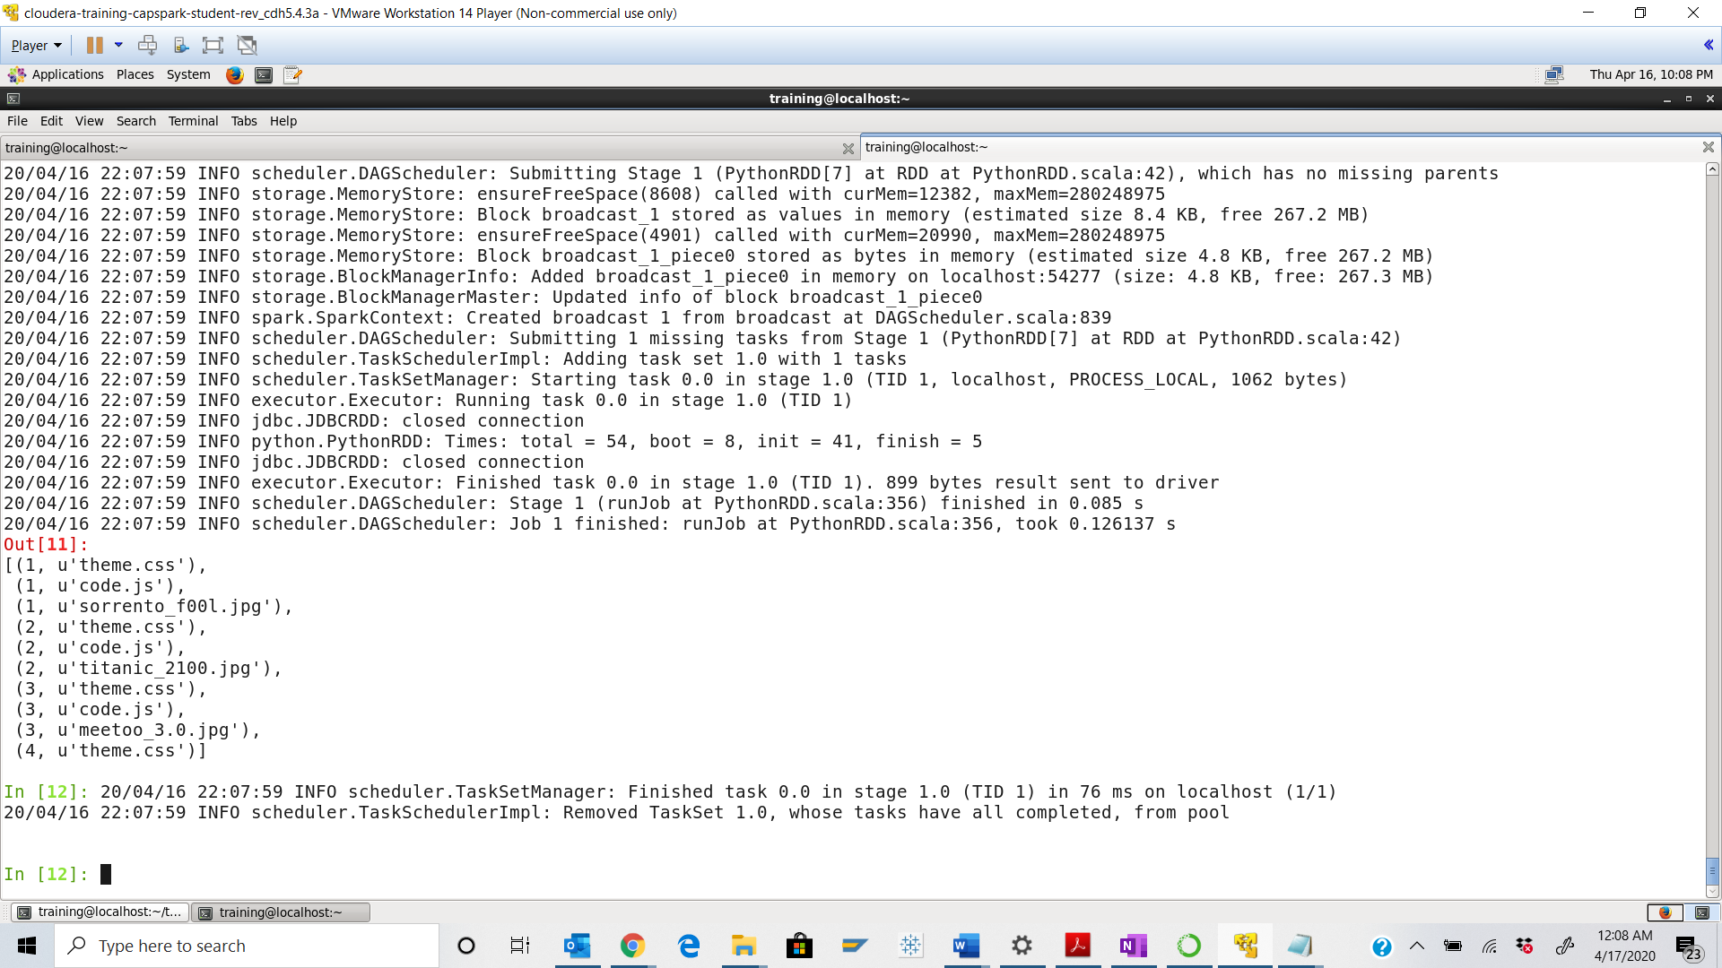

Step-19: Execute the following command at the python spark shell prompt:



Q. Execute the below command, take a screenshot of the python spark shell output and paste it below.



Explanation: We are creating a DataFrame from the manipulated RDD.

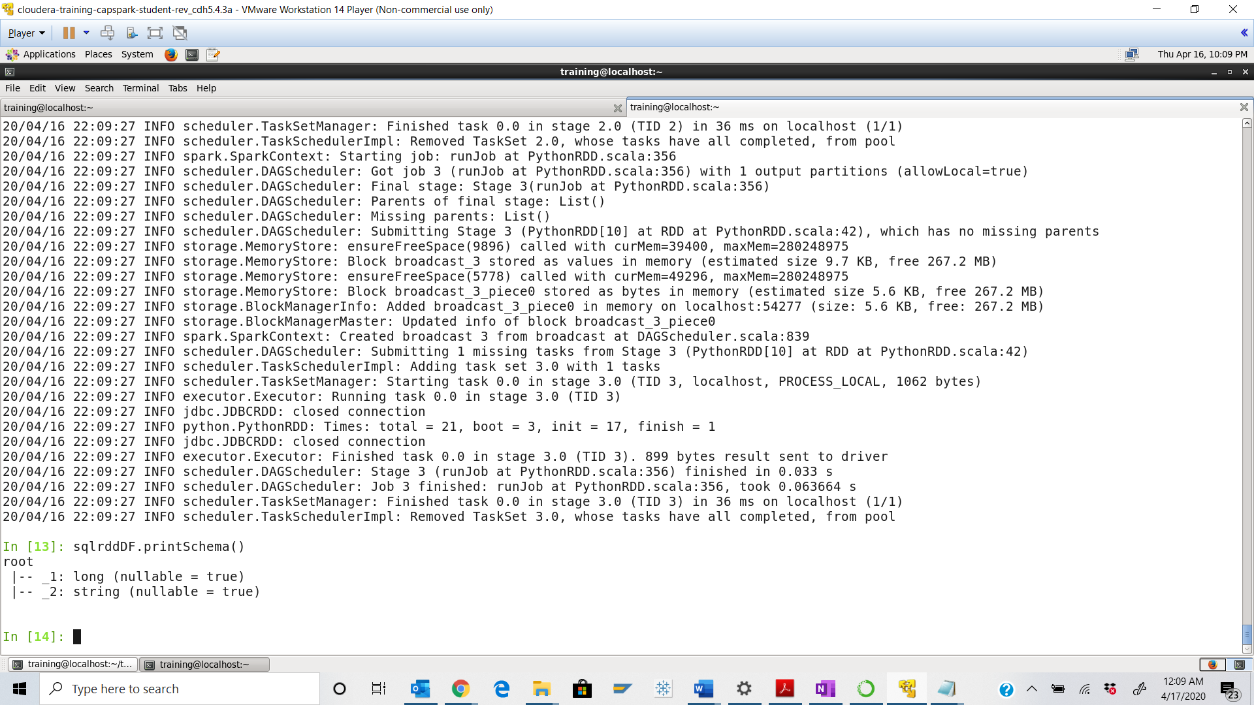 Step-20: Execute the following command at the python spark shell prompt:



Q. Execute the below command, take a screenshot of the python spark shell output and paste it below.



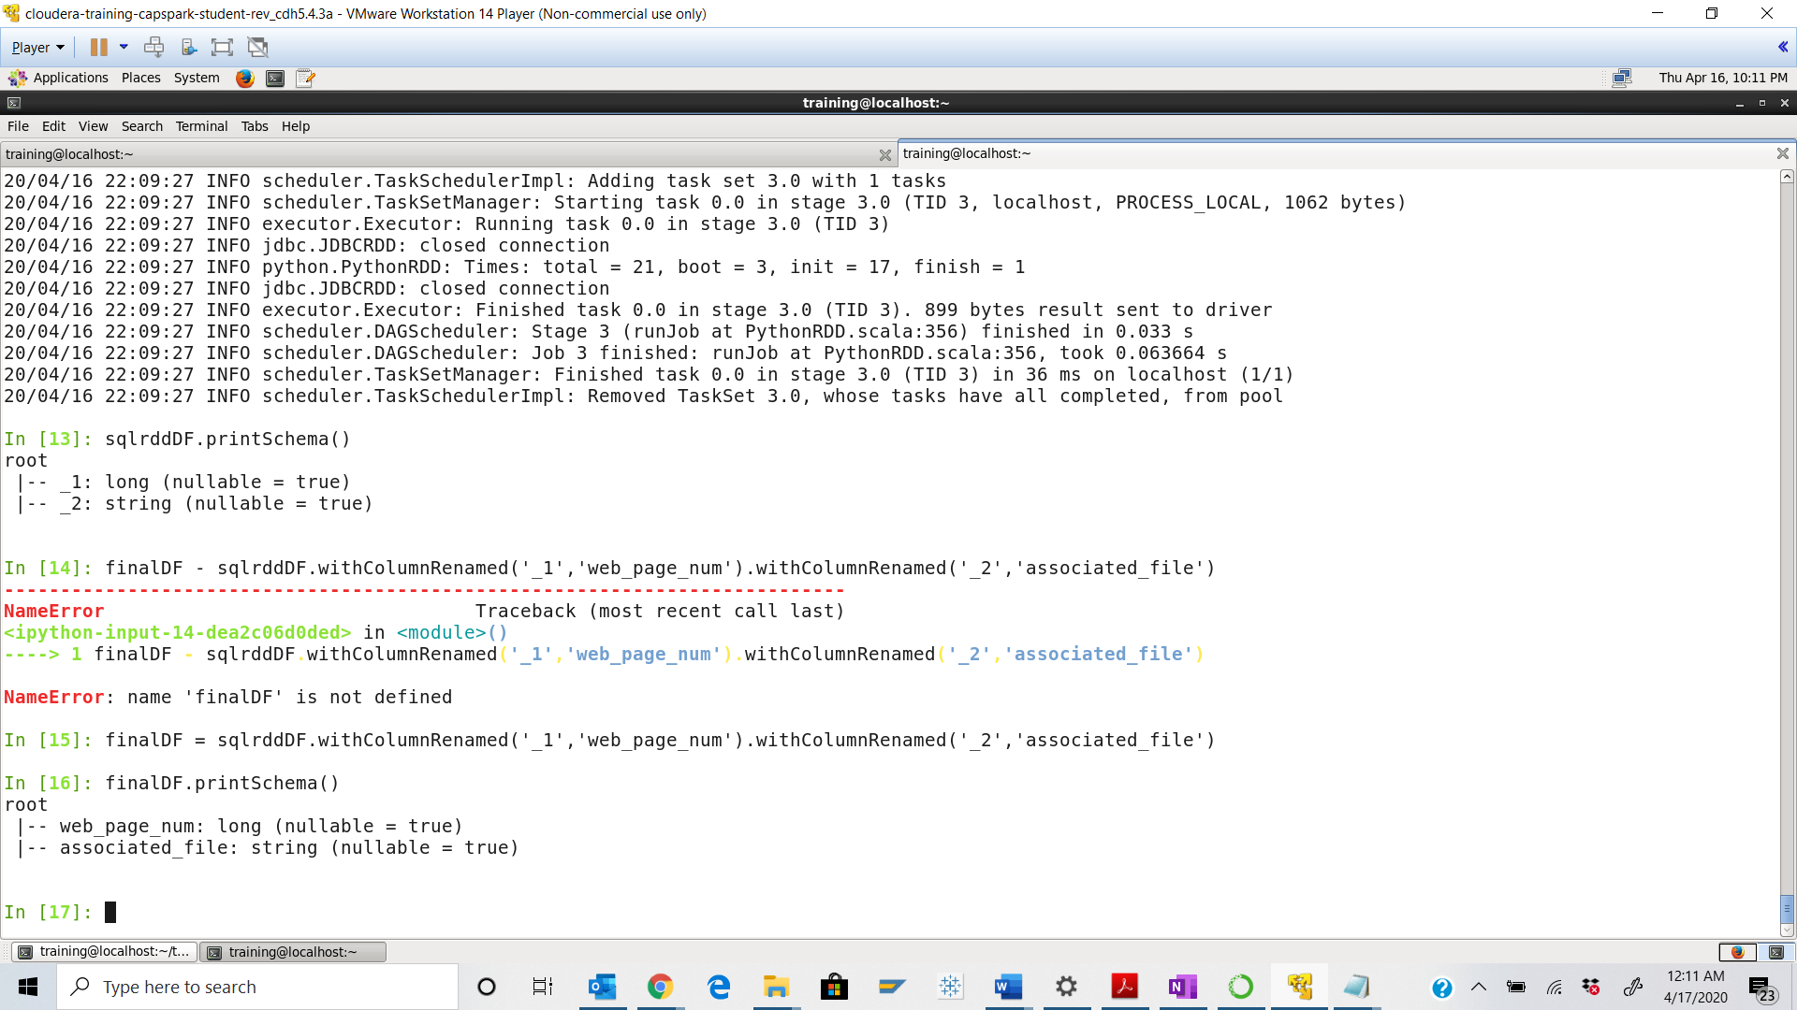

Step-21: Execute the following command at the python spark shell prompt:



Q. Using HUE File Browser, navigate to the following directory:

/loudacre_FirstName_LastName/webpage_files

Take a screenshot of the contents of the directory and paste it below.

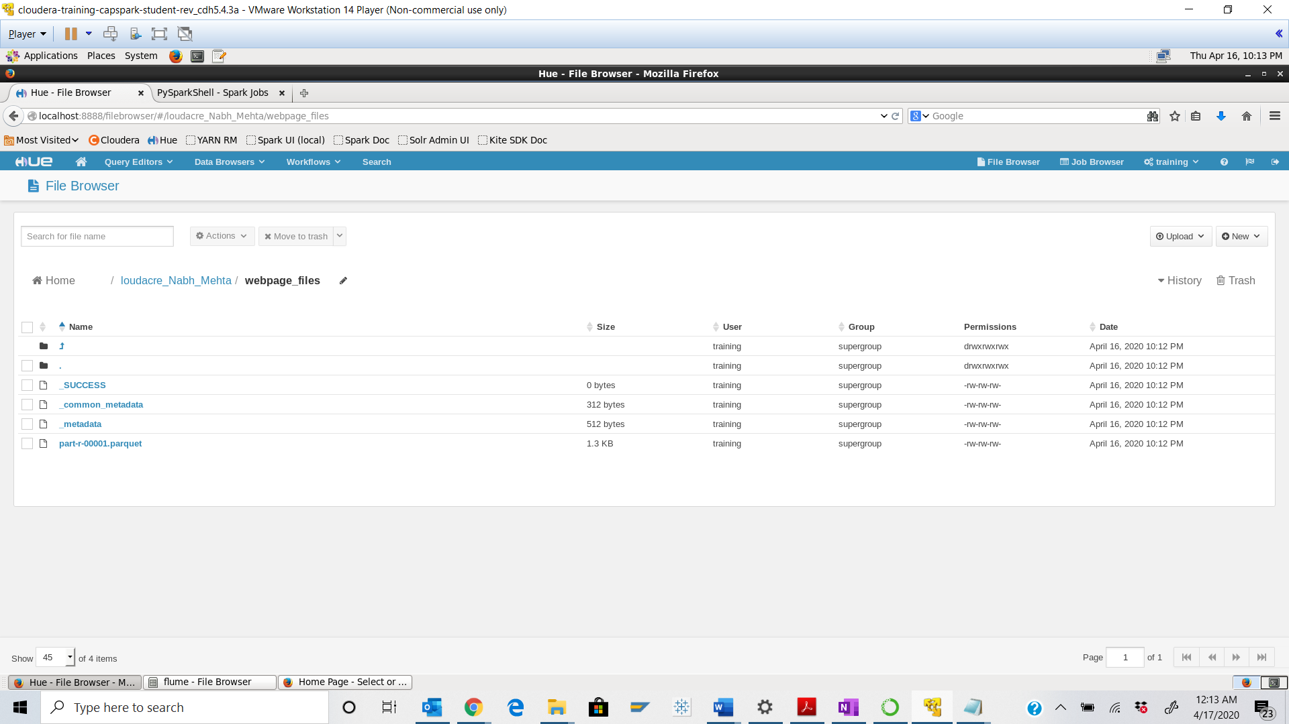 Step-22: Download the Checksum.zip file from eLearning into the downloads folder **IN** the Cloudera VM using Mozilla Firefox.

Step-23: Execute the following command:



Q. Now type the command and execute. Take a screenshot of the shell output, highlight the zip file and paste it below.

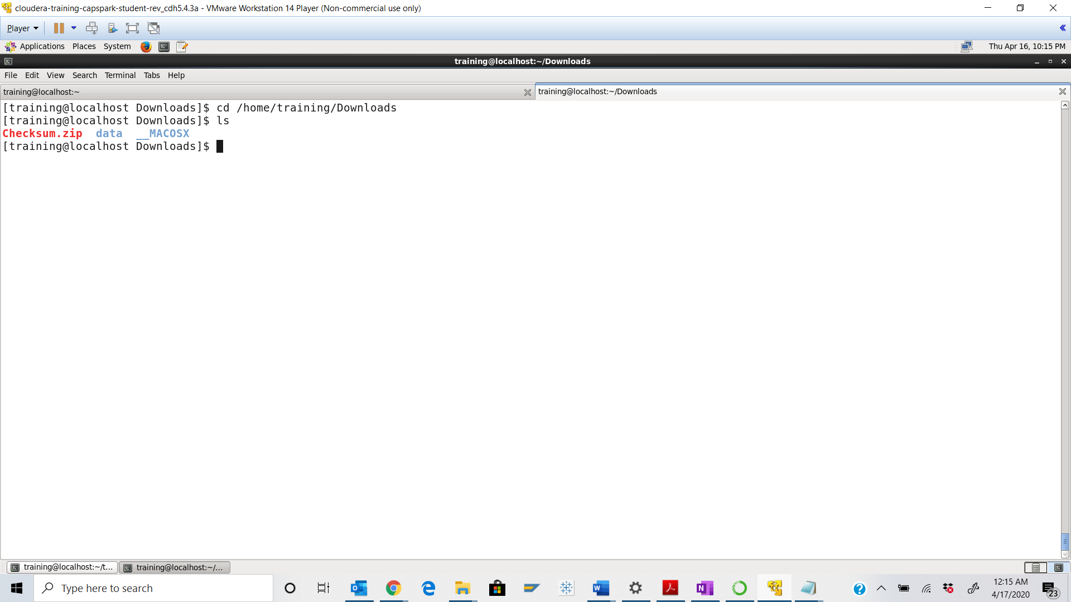



Step-24: Execute the following command at the shell prompt:



Q. Now type the command and execute. Take a screenshot of the shell output, highlight the contents of the zip file and paste it below.

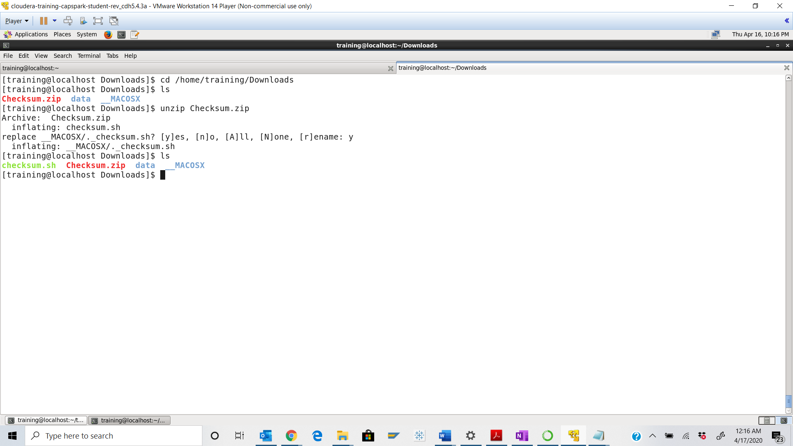



Step-25: Execute the following command at the shell prompt:

Then execute the following command:

Q. Take a screenshot of the shell output and paste it below.

Checksum value - e45c0dd0ecc447300be4bd951f900ce7

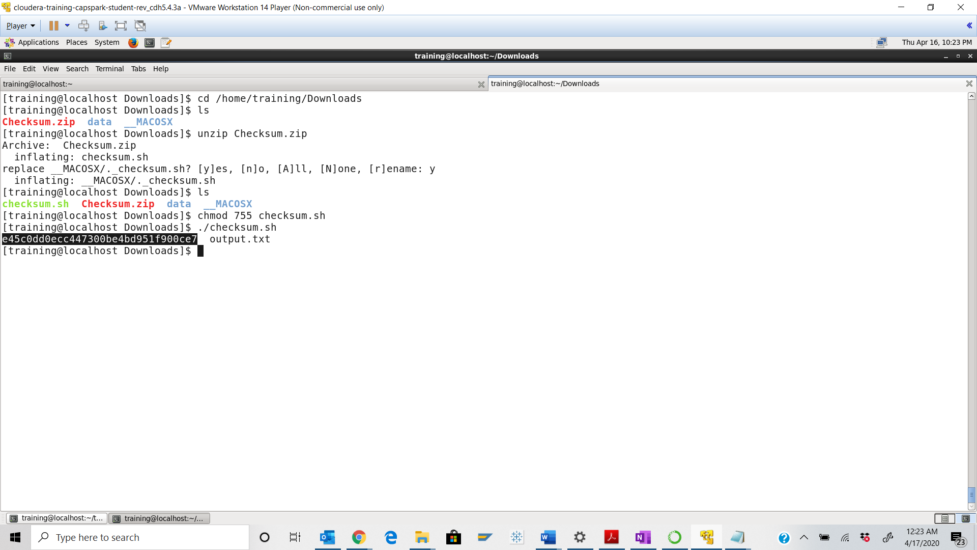

Step-26: Execute the following command at the shell prompt:

rm Checksum.zip checksum.sh output.txt



Q. Now type the command and execute. Take a screenshot of the shell output and paste it below.

